

Department of IT Engineering IT and MCA

**BRACT’S Vishwakarma Institute of Technology**

**Advanced Data Structure in Google Maps**

**Himanshu Pandey(20), Shyam Kawale(27), Abhijit Gawai(18), Nishant Bhat(41),Bhargav Pawar(46)**

Under the guidance of

**PROF. S.P. DONGRE**

CONTENTS:

* Introduction
* History
* Advanced Data Structure
* Which Graph?
* How Google Manages Attractive UI in Google Maps??
* Other Data Structure
* Shortest Path Algorithm
* Conclusion
* Reference

**Introduction:**

Google has been a turning point in people’s life. As we use an internet for many purposes like web search engines to find stuffs, we use maps to search a particular location, for educational purposes, in health care, Science, gaming or entertainment, for environment, communication, and even many more purposes.

**Google Maps:**

Google Maps is arguably one of the most famous Geospatial applications ever. It is developed by Google under web mapping service. It offers various wide range of services to users like 360° panoramic views of streets (Street View), real-time traffic conditions (Google Traffic), street maps and route planning for traveling and much more.

**History:**

Lars and Jens Eilstrup Rasmussen started “Where 2” company and designed Google map as a C++ desktop program. This company was then acquired by Google in 2004 and completely changed C++ desktop project into web application project. After additional acquisitions of a geospatial data visualization company and a real-time traffic analyzer, finally Google Maps was launched in February 2005.

**JUST HOW IMPORTANT WAS NAVIGATION TO THE SUCCESS OF DIGITAL MAPS? PERHAPS, A LOT! WE ALL USE DIGITAL MAPS TODAY AND MORE OFTEN THAN NOT, IT’S FOR NAVIGATION.**

-Google Engineer.

**Advanced Data Structure Used:**

Google maps uses graphs data structure for implementation of maps in real world , where intersection of two(or more) roads are considered to be a vertex and the road connecting two vertices is considered to be an edge, thus their navigation system is based on the algorithm to calculate the shortest path between two vertices.

**Which Graph???**

Edge Weighted Directed Graph is used to store online or offline map data. Locations on the map are considered as Vertices and the paths from one point to another (from one vertex to another) are considered as Edges. The total weight of a path is the sum of the weights of its edges .Quite obviously, since there can be millions of vertices and millions of edges, the really interesting thing would be the representation of this Edge Weighted Directed Graph.

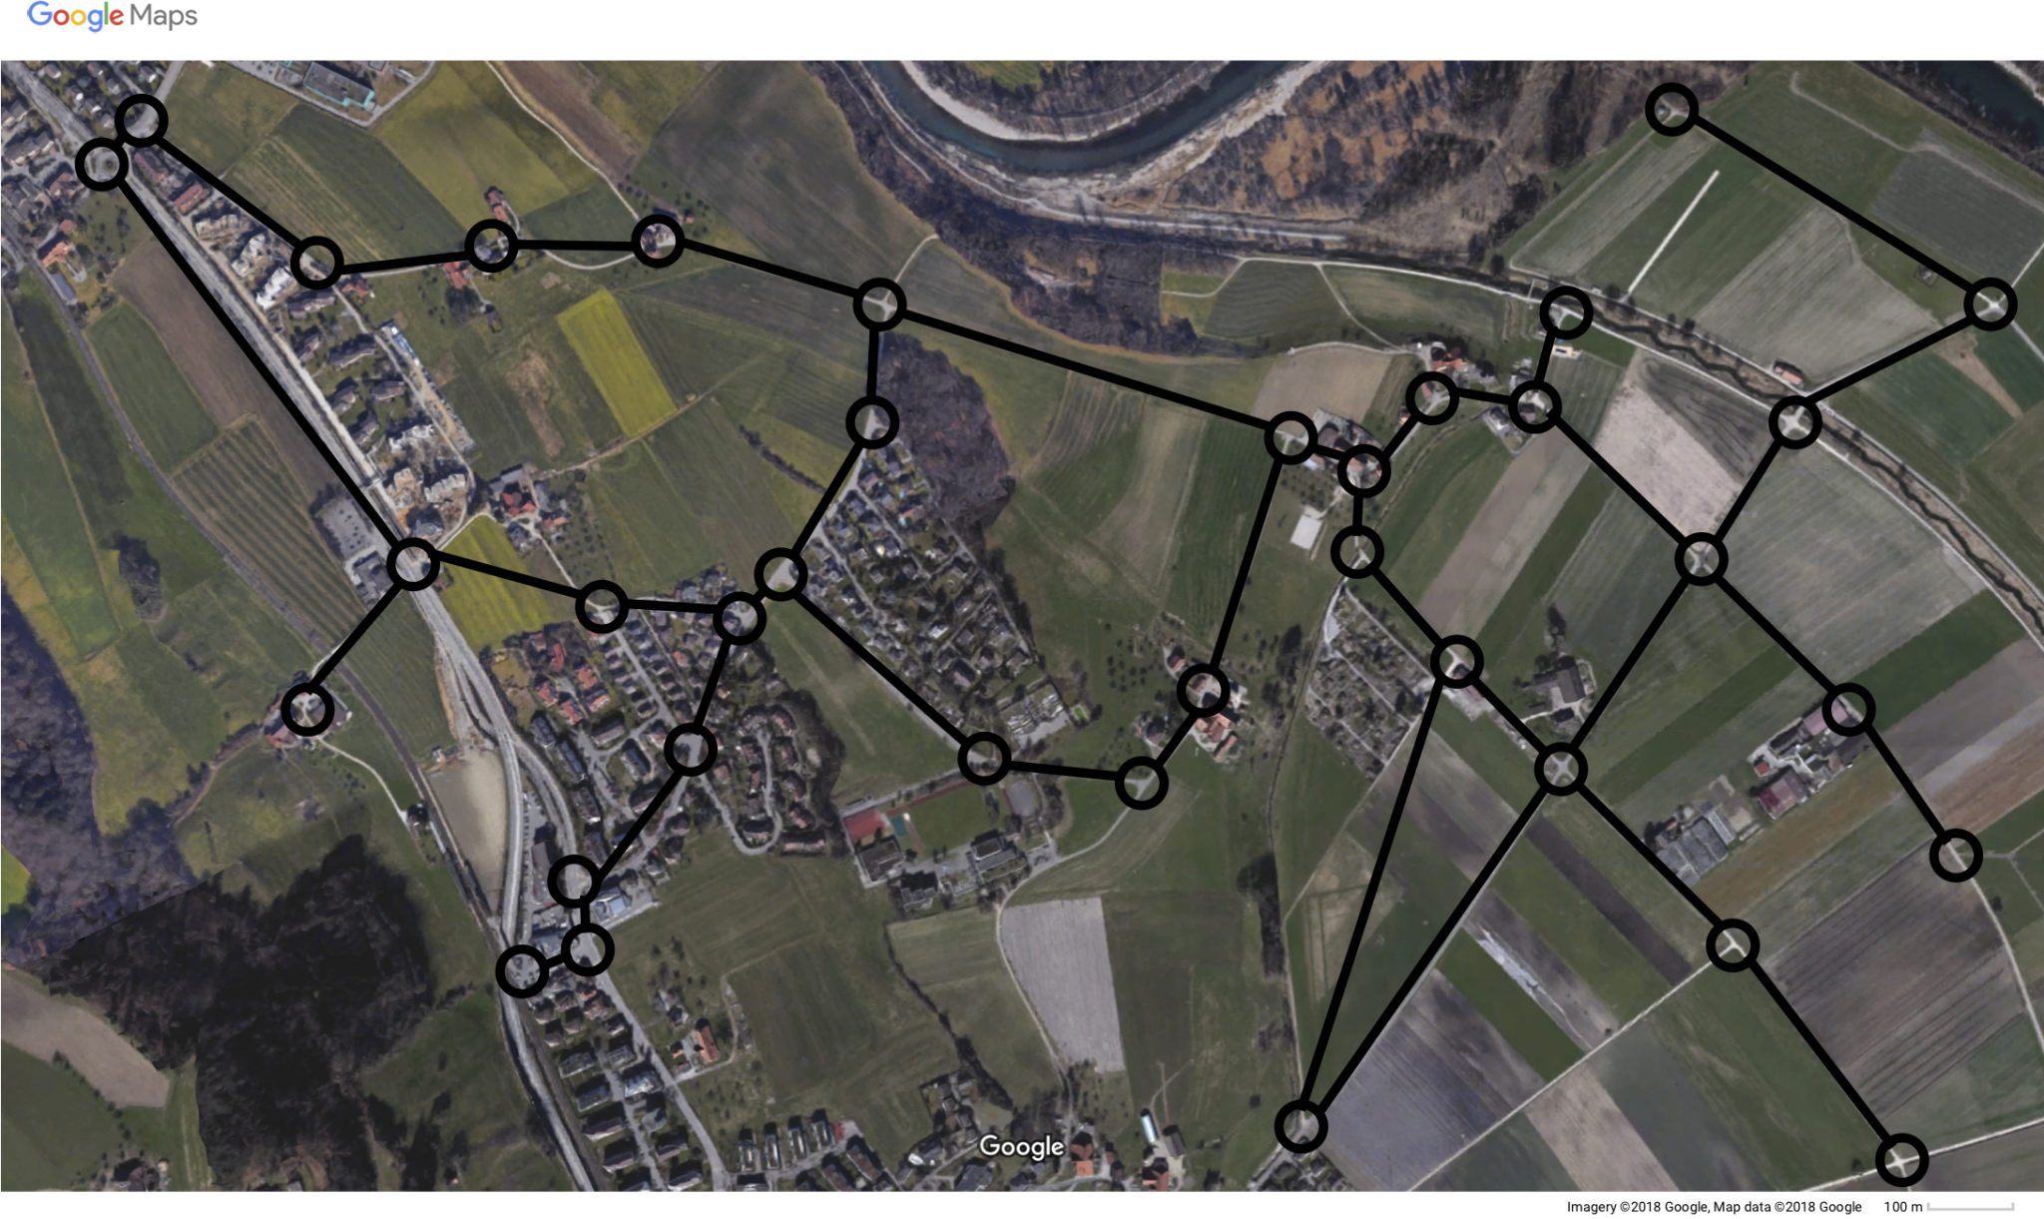

Fig. An image of a small town in Google Maps.

**So How Google Manages Attractive UI in Google Maps??**

Google Maps makes use of vector tiles data structure which incorporates vector data. Vector tiles are a way to deliver geographic data in small chunks to a browser or other client application. In vector tiles, data returned is a vector representation of the features in the tile.This vector data is then sent in the form of specific sized square tiles. Hence the map we see is the final result of these tiles.

**Other Data Structure:**

Obviously Google Maps don’t use this simple graphs data structure but they use the same concept behind these. Some of the known Advanced data structures that can be used for storing geographical maps are R-tree, R* tree. Beside this for offline map Google has developed the Keyhole Markup Language (KML), which can be imported into Google Earth/Maps and has easily modifiable, human readable syntax in XML form.

**Shortest path Algorithm used:**

The task of finding the efficient way from point A to point B can be reduced by finding the shortest path on a weighted graph. There are lot of different algorithms that can do this but the simplest of all is Dijkstra’s shortest path algorithm. Time complexity of this algorithm for the matrix representation is O(V^2), and O(ELogV) algorithm for adjacency list where V is no. of vertices and E is no. of Edges.

But Google uses advanced algorithm of all that is A* search algorithm. Worst case time complexity of this algorithm is O(E), where E is the number of edges in the graph. Also they uses D* search algorithm for real time path planning which is basically used for traffic avoidance in resulted path.

**Conclusion:**

*By using all these Advanced data structures and various Algorithms and Technologies , Google maps provides us with a best navigation tool efficiently no matter what part of the world you are using it in.*

**Reference:**

[1] <https://mathsection.com/how-google-maps-calculates-the-shortest-route/>

[2] <https://www.google.com/maps>

[3] <https://www.quora.com/>

[4] <https://www.researchgate.net/>